**The Dissertation**

**On**

**The Level of Food Satisfaction Among the Students of Begum Rokeya University, Rangpur.**



Course code: ECO 4207

(This Dissertation Submitted to The Department of Economics Under the Faculty of Social Science, Begum Rokeya University, Rangpur in Partial Fulfillment for The Requirement of The Degree of Honor’s of Social Science in Economics).

Supervisor:

Shaifuddin Khaled

Lecturer

Department of Economics

Begum Rokeya University, Rangpur.

Prepared By:

GROUP - H

|  |  |  |  |
| --- | --- | --- | --- |
| ID | NAME | ID | NAME |
| 1903006 | Most. Rahima Begum | 1903033 | Md. Alamgir |
| 1903011 | TANJILA AKTER | 1903038 | Md. Habibur Rahman |
| 1903014 | Monindro Nath Roy | 1903044 | Md. Anik Ahamed |
| 1903020 | Md. Nuruzzam | 1903054 | Animash Roy |
| 1903021 | Md. Zamirul Islam | 1903071 | Prodeep Kumar |
| 1903030 | Mst. Rojony Khatun | 1803042 | Hamidul Himandry |

DECLARATION

We the students of group H from Department of Economics, Bachelor of Social Science (BSS), bearing ID Begum Rokeya University, Rangpur, would like to declare that the paper entitled ''The level of food satisfaction of the students of Begum Rokeya University, Rangpur" is an authentic work prepared under the supervision of Saifuddin Khaled, Lecture, Department of Economics, Begum Rokeya University, Rangpur.

We also confirm that the paper is only prepared for our academic requirement not for other purpose and has not been submitted this paper in another place before.

Tanjila Akter

ID: 1903011

Most. Rahima

ID: 1903006

Monindro Nath Roy

ID: 1903014

Md. Nuruzzam

ID:1903020

Md. Alamgir

ID: 1903033

Md. Habibur Rahman

ID: 1903038

Mst. Rojony Khatun

ID: 1903030

Md. Zamirul Islam

ID: 1903006

Animash Roy

ID: 1903054

Hamidul Himandry

ID: 1803042

Md. Anik Ahamed

ID: 1903044

Prodeep Kumar

ID: 1903071

**Certificate of Supervisor**

This is to certify that the dissertation on "The level of food satisfaction among the students of Begum Rokeya University, Rangpur" has been prepared by the members of group H. BSS 4th Year, 2nd Semester, Session: 2019-20, Department of Economics, Begum Rokeya University, Rangpur, under my supervision and guidance. They have successfully completed this paper; I wish their success in every sphere of life.

Shaifuddin Khaled

Lecturer

Department of Economics

Begum Rokeya University, Rangpur

# **Acknowledgement**

At the outset, we would like to express gratitude to almighty Allah who created us and gave us the chance to learn and enhance knowledge as well as gave us courage and ability to prepare this dissertation paper.

Then, we would like to express our heartiest thank and gratitude to respected Shaifuddin Khaled our supervisor who gave us significant support and valuable advice to write our dissertation paper in the very short time.

We are also grateful and thankful to respected Prof. Dr. Morshed Hossain, the head of the Department for arranging this and allowing us to take part in this study.

We are also grateful to respected Kazi Newaz Mostafa sir, Md. Belal Uddin sir, Mintu Barua sir for their co-operation.

We are deeply pleased to all of our batch mates of 12th batch of Department of Economics Begum Rokeya University, Rangpur.

We would like to express our gratitude to our respected parents for preparing us to take part in such types of works.

We would like to thank all the students of the Institute who take part in providing data in our data collection time.

# **List Of Table**

Table 4.1 : Food Satisfaction Among Students of Begum Rokeya University, Rangpur 29

Table 4.2: Available nutritional food Among Students of Begum Rokeya University, Rangpur 30

# **List of Figure**

Figure 3.1: gender 20

Figure 3.2: Age of participants 21

Figure 3.3: Accommodation of participants 22

Figure 3.4: Family income 26

Figure 3.4: Personal income 28

Figure 4.1: Food consumer from the university cafeteria 33

Figure 4.2: food sanctification status from cafeteria 33

Figure 4.3: Factors affected food satisfaction 35

Figure 4.4: Factors for improving food satisfaction 38

# **Abstract**

This study has revealed that food satisfaction among the students of Begum Rokeya University, Rangpur and its impact on their health, academic performance, and overall experience in the campus. Food contributes significantly to welfare of the students yet few research on factors affecting food satisfaction exists in Bangladeshi public universities. This thus leaves a gap explaining perceptions students have on food quality, hygiene, pricing, and adequacy so that it can be improved in the university dining menus.

The study also seeks to answer some core issues of food satisfaction levels among students, factors affecting satisfaction and how such perceptions show variations with demographics like income and living conditions. Mixing quantitative methods and qualitative insights from interviews of various stakeholders like dining halls staff and administrators is an experimental approach undertaken to achieve these tight ends.

Widespread findings reflect that dissatisfaction forms strong solid evidence which approximately 65.7 percent of students satisfied or not satisfied with food quality, hygiene, pricing and variety. Family and personal income and cleanliness and pricing were the key identifying dimensions. More than 61.5 percent cited limited accessibility to healthy meals, which brought to the fore concerns regarding availability and the dieting system. Finally, food service quality is dramatically affected by increasing prices plus not enough manpower.

The study is significant since it signifies that the multi-fold factors that culminate to meal satisfaction include affordability of meals, hygiene, and diversity in terms of meal choices within the higher education levels of Bangladesh. Actionable recommendations like subsidy, hygiene standards, and more menus are also prescriptive ones, which the university could take into consideration for enhancing students' meal satisfaction. In effect, the university can address the issue and subsequently assist its studen

**Table of Contents**

Acknowledgement 4

List Of Table 5

List of Figure 6

Abstract 7

INTRODUCTION 1

1. Introduction 2

1.1 Background of the study: 2

1.2 Rationale of the Study: 3

1.3 Problem Statement: 3

1.4 Research Questions: 4

1.5 Research Objectives: 4

1.6 Significance of the study: 4

1.7 Brief background of the concept: 5

7

2. Literature review 8

3. Research methodology 17

3.1 Research design 17

3.2 Research method 18

3.3 Data collection techniques 18

3.4 Sampling 20

3.5 Data analysis method 23

3.6 Ethical consideration and data reliability and validity 24

4. Result and discussion: 26

4.1 Family background: 26

4.2 Personal income: 28

4.3 Food Satisfaction Among Students : 29

4.4 Availability of Nutritional Food Among Students: 30

4.5 Food consumption and satisfaction from university cafeteria: 33

4.6 Factors influencing students’ food satisfaction: 35

4.7 Suggestion from students’ point of view: 38

4.8 Case study 42

4.9 Result Discussion and Suggestion: 46

4.9.1 Discussion 46

4.9.2 Suggestion 47

5. Conclusion: 50

6. Limitations and further research: 54

REFERENCES 56

**APPENDIX** 60

# INTRODUCTION

# **1. Introduction**

## **1.1 Background of the study:**

The background of the study on food satisfaction at Begum Rokeya University is rooted in the recognition of the critical role that food services play in shaping students' overall campus experience, health, and academic performance. Despite the importance of this aspect, there is a notable gap in research regarding food satisfaction levels among students in Bangladeshi public universities, particularly at Begum Rokeya University.

Students often spend significant amounts of time on campus, making access to quality, affordable, and nutritious food essential for their well-being. Poor food satisfaction can lead to negative outcomes, including diminished physical and mental health, lower academic performance, and reduced engagement in university life. Factors such as food quality, variety, hygiene, pricing, and availability are crucial in determining students' satisfaction but have not been thoroughly explored in this context.

Additionally, the study aims to address the challenges faced by economically disadvantaged students regarding food accessibility and affordability. By examining food satisfaction across different demographic groups, the research seeks to ensure that the diverse needs and preferences of the student body are met. Ultimately, the findings of this study are intended to inform university decision-makers and contribute to creating a healthier, more supportive campus environment at Begum Rokeya University, thereby enhancing the overall student experience and promoting better health outcomes and academic success

## **1.2 Rationale of the Study:**

A major consideration within the domain of welfare is the food satisfaction of students, which affects their performance in universities and their daily lives at the campus. At the Begum Rokeya University in Rangpur, standardized and healthy working food services have been proved vital for students. The objective of this study is to depict food satisfaction level at college and seek what factors affecting food. Therefore, qualifies their utterances, they can work towards improving quality, variety, hygiene as well as the price of food sold at the institution. This makes the availability of healthy meals indispensable as well. This research will help give further insights to facilitate this, towards not just the student experience but also, health and academic performance and retention. Meet the needs of the student population through service satisfaction across different groups of students.

## **1.3 Problem Statement:**

The food assists a lot in the campus life, health and studies of students of Begum Rokeya University, Rangpur. There is however a knowledge gap when it comes to food satisfaction and determinants of food satisfaction. Other issues related to the food like variety, quality and hygiene, proclamations of price, and availability have not been examined also. However, there is limited work done on the relationship between food satisfaction and the detrimental and health and academic outcome in students’ leading to negative out comes and raises issue. Concerning low socio-economic status students, accessibility and affordability to food is the greatest challenge and there may be skewed free nutritious meals meant for only certain children, however, still it is not known whether all such children are provided with nutritious food and if so in adequate amounts.

## **1.4 Research Questions:**

The study on food satisfaction among students at Begum Rokeya University, Rangpur, several key research questions, which may include:

1. What is the level of food satisfaction among students at Begum Rokeya University, Rangpur?
2. What factors mainly impact students' food satisfaction?
3. What demographic factors (e.g., age, gender, family background) influence students' food preferences and satisfaction?
4. What changes are to be made to incise food services in university dining?

## **1.5 Research Objectives:**

* To evaluate the overall satisfaction level of students with the food provided at Begum Rokeya University, Rangpur.
* To assess the accessibility and availability of food options on and around campus.
* To analyze the factors that impact on food satisfaction, including taste, quality, variety, hygiene, and pricing.
* To compare the satisfaction levels of various demographic groups, such as gender, year of study, and family status.

## **1.6 Significance of the study:**

Understanding food satisfaction among students in the institution is decisive towards improving student welfare, boosting academic performances and unearthing actionable information for university administrators, food vendors and policymakers relevant with immediate processing. It is intended to determine what is and what is not supporting satisfaction as well as the extent that students have access to healthy foods. Secondly, the outcomes will contribute to creating strategies to increase student satisfaction through improving the quality diversity hygiene and cost of foods services on campus. It will be a study that does not only talk about diversity and accessibility but also reaches young kids of every race (but particularly economically disadvantaged) and shows them the path. It is one of the first to explore food satisfaction in Bangladeshi public universities and provides a way forward, making a unique contribution to enrich the available literature on university student welfare and function of food services in HEI.

## **1.7 Brief background of the concept:**

Student need to get the food component right. You cannot overlook that satisfaction with what you eat has a huge impact on your life as an undergraduate. The determining factors are quality, variety, hygiene, price and availability. Food dissatisfaction can have severe repercussions from diminishing both physical and mental health to underperforming in academics leading to lower engagement levels not only the classes but the university life as a whole. Taking into account the needs of different types of student groups, especially economically disadvantaged ones might improve food services and contribute to a healthier, friendlier campus community.

Mainly the present students, future students and the authority are the beneficiaries of this study. Students at Begum Rokeya University, especially those from low-income families, will benefit from the study on food satisfaction since it will provide them with insights into their dietary choices and nutritional needs. Actionable data will help university officials make judgments on policies that improve the welfare and mental health of their students. Food vendors can enhance their business methods by customizing their goods in response to input from students. Evidence to support programs aiming at enhancing food quality and accessibility in educational institutions will be provided to policymakers. Ultimately, the research aims to build a healthy campus atmosphere that positively improves academic achievement and overall student participation.

LITERATURE REVIEW

# 

# 2. Literature review

Variables demographic status such as age, sex, race, and academic standing have an impact on food security. Thirty-five percent of participants in research examining food security among undergraduate students at four Illinois institutions reported experiencing food insecurity. The status of food security was found to be significantly correlated with a number of socio-demographic variables, such as dwelling location, loan utilization, grade point average, and race. These results demonstrate the necessity of providing pupils experiencing food insecurity with focused support services.(Morris et al., 2016)

The results show that natural disasters, ineffective governance, dense population, and fast urbanization are posing growing threats to food security for Bangladesh's severely poor households. The concept of food security has advanced thanks to the 3As paradigm (availability, accessibility, and application); nonetheless, it does not sufficiently address the connections between food-related and non-food issues. The study makes the case for an interpretative approach that prioritizes the viewpoints of households experiencing food insecurity, especially those in coastal Southwest regions. The research attempts to capture the complex, multidimensional character of food security and produce context-specific insights from these communities by utilizing qualitative methodologies that are centered on listening and understanding. Overall, the results highlight the need for a more comprehensive understanding of food security that takes into account both food and non-food aspects and acknowledges that practical solutions must be based on the experiences and realities of people who will be most impacted.(Rahman & Zaman, n.d.)

With an emphasis on the value of health for students' ability to concentrate in class and general well-being, the study attempts to evaluate the features of food services at public university canteens. Based on survey data from a northwest Pennsylvania college, the results show that three major factors affect how satisfied students are: having good interactions with staff makes a big difference in students' experiences; having high-quality, nutrient-dense food is important for student satisfaction; and having fair prices is important for drawing students to the canteen.   
  
The report also notes that the general environment, personnel response, and cleanliness are significant factors in determining satisfaction. Food service managers may increase the value provided to students and, in turn, improve their educational experience by concentrating on these factors.(Raihen et al., 2023a)

The Food for Education (FFE) program was started by the Bangladeshi government in 1993. Its objectives are to increase enrollment, promote attendance, lower dropout rates, and improve the quality of education by giving impoverished families free monthly rations of rice or wheat in exchange for their children attending school. An study by the International Food Policy Research Institute (IFPRI) reveals that the program has mostly fulfilled its enrollment and attendance targets, especially for females; nonetheless, issues persist in educational quality. Even though the FFE program is designed to help low-income homes, many impoverished families continue to be left out, and some non-poor households are inadvertently included. Furthermore, it is discovered that the existing private-dealer-based food ration distribution system is ineffective, underscoring the necessity for enhancements to the targeting and distribution procedures.(Ahmed, n.d.)

The objective of the research was to determine the frequency of food insecurity among graduate and undergraduate students at a Midwestern institution and investigate its relationships with traits found in the socioecological model (SEM). Undergraduates were more likely than graduates to experience food insecurity. Significant factors that predicted food insecurity for undergraduates were living off-campus, receiving financial aid, being non-White, having a job, and the cost of food (p < 0.001). Graduate students reported food insecurity connected to Asian self-identification, job, food expenses, insufficient time to prepare meals, and a shortage of food suitable for dietary needs (p < 0.001). Students who were food insecure were more inclined to buy cheaper food, and nearly half of them asked friends or family for help with food. Furthermore, students who experienced food insecurity said that they would like more information on meal planning and budgeting, and a greater percentage of graduate students knew about and used food banks. The results indicate that in order to effectively address food poverty, colleges should adopt institutional and policy adjustments that are customized to the unique needs of undergraduates and graduates.(Hiller et al., 2021)

College students had difficulties like locked dorms and higher unemployment during the COVID-19 limitations in the spring of 2020, which led many of them to move back in with their family. This study looked at how Iowa State University students' living conditions and levels of food security changed over time. 1,434 students between the ages of 18 and 30 who had visited the campus prior to its closure responded to an email survey.

The number of students living with parents or guardians increased by 44%, and these students also reported lower rates of food insecurity, less stress, and more home-cooked meals. These are some of the key findings. Students who lived independently, on the other hand, had greater levels of food insecurity, stress, poorer health, and longer workweeks. A total of 17% of students reported experiencing food insecurity. Important associations were found between food insecurity and non-White ethnicity, reduced cooking self-efficacy, undergraduate status, financial aid receipt, employment, stress levels, unaltered housing arrangements after closure, and a higher intake of fast food or takeout. There were additional obstacles to food access for these students. Comprehending these variables can direct the creation of focused assistance programs for university attendees facing comparable future situations.(Davitt et al., 2021)

This paper employing longitudinal data from 1,800 rural families between 2007 and 2010, the combined effects of the global food and financial crises on household food security and economic well-being in Bangladesh. According to the study, food insecurity in rural regions was made much worse by the steep increase in food prices in 2007–2008. Additionally, there is some indication that the subsequent global economic collapse in 2009 had an even greater impact on food security. However, because of changes in the labor and commodity markets, growth in the local economy, and successful domestic policies, the negative consequences of these crises subsided with time and had no long-lasting negative repercussions on the state of the economy. While poorer people and farming communities were largely impacted in the short term by increased food costs, the farming industry as a whole benefited more fairly over time.(Akter & Basher, n.d.)

The analysis, which makes use of data from the Pakistan Rural Household Panel Survey, shows that, in both aggregated and dis-aggregated models, higher household income positively improves food security. On the other hand, food inflation lowers consumption of most food items and has a negative impact on food security. Food intake in households is found to be positively impacted by BISP cash transfers. Furthermore, food security and household size have a negative correlation, although household literacy has a positive correlation. Improving education may both directly and indirectly increase food security by raising income. In addition to emphasizing government efforts to manage the pricing of staple items such wheat flour, rice, vegetables, and sugar—which are particularly susceptible to changes in income and price—the study suggests raising BISP cash levels and broadening beneficiary coverage.(Hassan, n.d.)

The effect of increasing food prices on urban poverty in 72 developing nations, calculating the shift in the price of poverty alleviation through the evaluation of the poverty deficit (PD)—the amount of money required to totally eliminate poverty with precise targeting. According to the research, the extra expense of combating urban poverty is less than 0.2% of GDP for the majority of countries, while it can reach 3% in the worst-affected ones. While very few new households are entering poverty as a result of the price increases, the real income declines of those households who were already impoverished before the price increases are the primary cause of the increase in PD. Therefore, it is more efficient to expand current programs rather than concentrate on locating more homeless individuals in nations with efficient transfer channels**.**(Dessus et al., 2008)

High inflation severely restricts the population's ability to afford food in Bangladesh, especially for lower-class and lower-middle-class households. One significant external element driving inflation has been recognized as the war between Russia and Ukraine. Rising prices are attributed to internal factors such as inefficient domestic food production, syndicate activities, and inadequate policies. Inflation has forced households of all income levels to raise their food expenses. People in the lower and upper middle classes spend about half, if not more than half, of their monthly income on food. Many people no longer can purchase common food staples like rice, onions, and potatoes, especially those in the lower and higher middle income brackets.(Uddin, n.d.)

With a focus on the value of health for students' academic and personal well-being, the study tries to assess the features of food service at public university canteens. Based on survey information gathered from a college in northwest Pennsylvania, a model was created. Results show that the three main factors affecting student happiness are pricing, food quality, and staff behavior. Furthermore, the general surroundings, responsiveness, and cleanliness are important factors. Food service managers can improve value and happiness by taking these factors into account, which will ultimately improve the educational experiences of students.(Raihen et al., 2023b)

In Bangladesh, rice is an essential food staple that accounts for 71% of total caloric consumption, 58% of protein, and 15% of the income of rural households. Poor families spend forty percent of their food budget on rice, which is purchased by more than half of households. Food insecurity and poverty are made worse by rising rice prices, especially for low-income households. The 2008 price increase forced an additional 9 million people into poverty, according to this study, which also looks at the reasons of rice price inflation and how it affects rural lifestyles.

According to the study's findings, efforts to reduce poverty and provide food security are at risk due to the likelihood that rice prices would stay high.(Khanam et al., 2015)

In view of the going on crisis in Venezuela, the study looks at the relationship between socioeconomic position, food security, and dietary diversity among sociology students at the Central University of Venezuela (UCV). The study discovered that although 82.6% of participants were from wealthy to middle-class families, 85.9% of them had limited dietary diversity and 85.9% reported food insecurity. Interestingly, food security and dietary variety were not correlated with socioeconomic class; nonetheless, individuals who experienced food security were 3.92 times more likely to eat a diverse diet than those who faced moderate or severe food insecurity. The results show that these students are in a critical multidimensional food situation, implying that their right to food is being infringed upon, which may have an effect on their academic performance and tenacity in their studies.(Hernández & Camardiel, 2021)

This article analyzes rice quality on rice prices, how rice quality affects food security and sustainability. This paper also estimates the economic value of the selected intrinsic rice quality attributes deemed of importance in Bangladesh and the food security and environmental implications of producing milled rice with the quality characteristics identified in this study relative to what is currently offered in the market. The result of this paper suggest that different attribute have a significant impact on rice prices. And increased in rice price has a negative effect on food security.(Saha et al., 2021)

Food security in Bangladesh, even with improved production, imports still make up roughly 10% of the food supply, with noticeable shortages in products like meat, oil-seeds, and pulses. Poverty rates have decreased as a result of improvements in food access on an economic, physical, and social level. However, income disparity persists, and while overall food consumption has risen, malnutrition difficulties remain, with considerable levels of stunting and underweight.   
  
In order to fight hunger and malnutrition, the study highlights the significance of agriculture interventions that are responsive to nutrition. Increasing micro-nutrients, promoting nutrient-dense food research, fortification, and optimizing home processing to increase micro nutrient bio-availability are among suggested solutions. These strategies are seen to be long-term ways to improve the nation's food security and nutrition.(Talukder & Anik, n.d.)

To conclude, a variety of research analyzing different demographics and circumstances highlight the complex issues surrounding food security. According to the research, a household's and student's level of food security is mostly determined by institutional assistance, economic circumstances, and demographic variables. Particularly impacted by their housing arrangements and financial background, college students have notable rates of food insecurity, which necessitates the provision of focused support programs. The impact of rising food costs, incompetent administration, and natural catastrophes on Bangladesh's impoverished households underscores the necessity for all-encompassing measures that tackle socioeconomic concerns that are linked to food. There is still inadequacy in the targeting and delivery of programs like the Food for Education project, despite modest progress in raising school attendance. All things considered, these studies support modifying policies and developing educational programs to better meet the specific requirements of various groups. They emphasize that in order to promote better health and well-being in communities, effective interventions must take into account the intricate interactions between various factors that affect food security.

RESEARCH METHODOLOGY

# 3. Research methodology

This section describes the method used for the study. It includes research design, sampling design, data collection methods, and methodology.

## **3.1 Research design**

The study uses both quantitative and qualitative research methodology to look at the level of food satisfaction of the students of Begum Rokeya University, Rangpur. These strategies work well because they make it possible to gather objectively evaluated statistical data that gives precise insights into the elements influencing the level of food satisfaction of the students the meal they consume every day.

We will be able to evaluate the current condition of food satisfaction and its determinants by gathering data from the various sample of students through the use of cross-sectional survey approach. This layout will make it easier to comprehend in detail how different elements, such as inflation, impact the foods that students choose to eat and how satisfied they are overall. With the diverse student body as its emphasis, the study seeks to identify trends and insights that can guide enhancements to students’ food consuming system.

Utilizing a combination of qualitative and quantitative research approaches, this study aims to provide a thorough grasp of Begum Rokeya University, Rangpur students' meal satisfaction level. By merging both approaches, the study seeks to record students' complex experiences and viewpoints in addition to quantifiable satisfaction levels. Structured surveys are used in the quantitative component to collect demographic data and find general satisfaction. This allows statistical studies to find trends and correlations. In parallel, a deeper investigation of students' individual experiences and viewpoints on food services will be conducted through the use of qualitative techniques including focus groups and interviews. Through the use of both approaches, it will be possible to gain a more comprehensive understanding of the variables affecting level of food satisfaction, which will ultimately produce insights that can be put to use in order to improve food services and the entire campus experience for students.

## **3.2 Research method**

The study employs a stratified random sampling approach for quantitative analysis to examine the level of food satisfaction among students at Begum Rokeya University, Rangpur. This method ensures that demographic groups—such as gender, age, and economic background—are proportionately represented, enabling meaningful comparisons across these segments. Survey data is collected from selected participants, providing insight into the diverse experiences of students based on accommodation types (university hall, hostel, others) and economic factors.

For qualitative data collection, judgmental sampling is used to select specific participants such as dining hall provosts, hostel owners, and students, chosen based on their relevance and ability to provide detailed, contextual insights into the food satisfaction dynamics. Structured surveys, case studies, and interviews serve as the primary data collection tools. Analytical methods include both descriptive (e.g., bar graphs, pie charts) and inferential statistics to evaluate demographic factors and their correlation with food satisfaction comprehensively.

## **3.3 Data collection techniques**

A 'questionnaire' was used as the main to collect data for this investigation. This strategy was selected because it was used effectively to collect both quantitative and qualitative data from a large number of participants in a condensed amount of time. For the case studies we employ judgmental sampling carefully to select participants based on specific characteristics relevant to our research. Our data collection focuses on selected students residing in the university hall, mess, and others, ensuring a diverse representation of experiences. Additionally, we included the dining provost of the hall, who offered information about meal services and communal dining experiences. This comprehensive approach allows us to obtain and to reach, targeted data that enhance our understanding of the student’s environment.  
  
**Questionnaire Design:** The questionnaire was created to include subjects like demographics, attitudes, and habits and to be in line with the goals of the study.   
- A "closed-ended" multiple-choice questions was used to gather quantifiable information as well as observations.   
- To make sure the questions were reliable, relevant, and clear, a small sample was used for pre-testing.   
  
**Distribution**: The survey was disseminated via email, hard copies, and online tools like Google Forms.   
The sample method, random sampling, and stratified sampling were used to choose the participants.   
- The questionnaire received responses from 320 participants in total.

**Process for Implementation:**  
Before filling out the questionnaire, participants were briefed about the study's objectives and asked for their consent.  
To give respondents enough time to respond, the survey was sent over a period of three weeks.  
We spoke with them and asked them to respond in order to promote involvement.

## **3.4 Sampling**

The demographic segmentation of the student body will be based on two primary factors: gender and age. The results of the survey will be meaningfully comparable according to this targeted stratification, which will provide targeted insights on food satisfaction across various age groups and genders.

Gender of the participant:

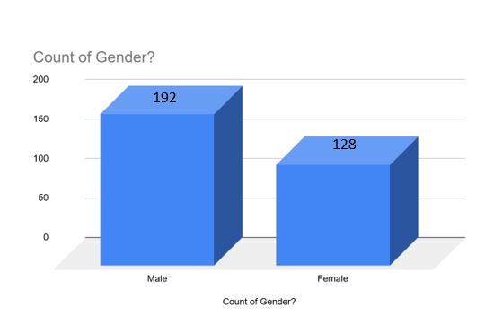

Figure 3.1: gender

Both male and female individuals fall into the gender demographic group for our study. The y-axis shows the count, which ranges from 0 to 200 in steps of 50. The x-axis is labeled "Count of Gender."   
  
While the bar for "Female" hits about 128, the bar for "Male" reaches about 192. This suggests that the data set this graph represents has more men than women.   
This graph might be pertinent to our dissertation topic on "Food Satisfaction," provided that the study's goal is to examine food satisfaction in relation to gender. Understanding the sample size and making sure that gender representation is taken into account in the analysis are made possible by the graph, which displays the distribution of male and female participants. Interpreting the results and drawing conclusions about meal satisfaction that are gender-specific can be aided by this demographic data.

Age:

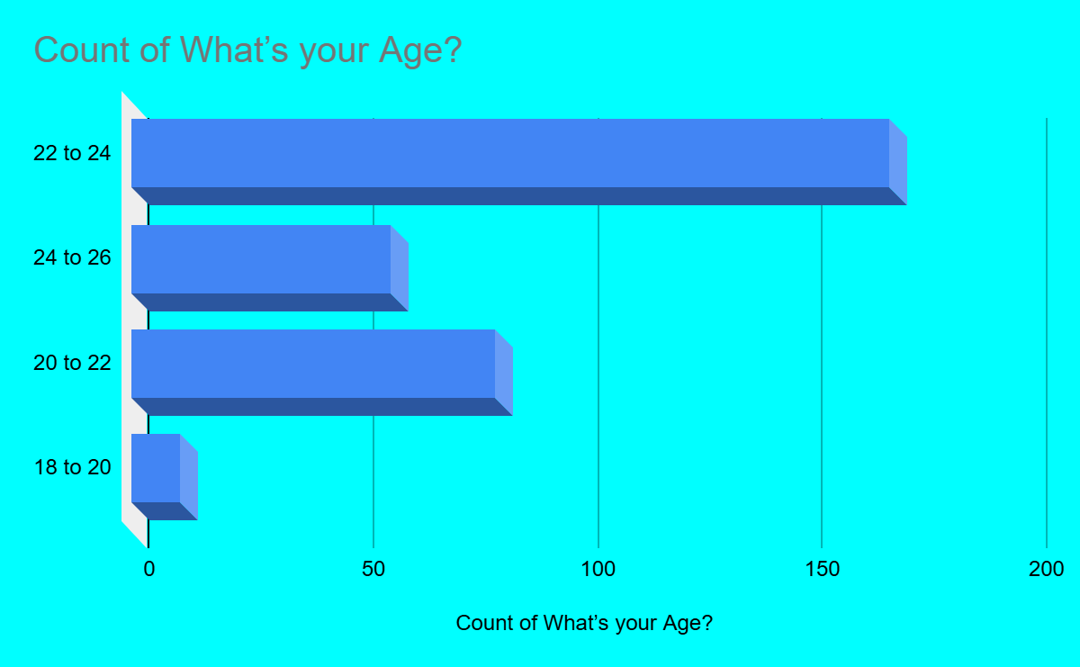

Figure 3.2: Age of participants

the respondents' age distribution across several age groups. The y-axis shows the age groups: 18 to 20, 20 to 22, 22 to 24, and 24 to 26. The x-axis shows the number of responses, which ranges from 0 to 200.

The highest count of respondents is **22** to **24** age group. The **20** to **22** age group is the second largest. The **24** to **26** age group comes next. The **18** to **20** age group has the lowest count.

This graph is pertinent to the dissertation topic "Food Satisfaction among the Students of Begum Rokeya University, Rangpur," since it offers crucial demographic data regarding the age distribution of the students polled. Analyzing food satisfaction levels requires an understanding of the age distribution because preferences and levels of satisfaction might differ greatly among age groups. The majority of respondents, according to the graph, are between the ages of 22 and 24, which may have an impact on the general trends in satisfaction. This data facilitates more accurate interpretation of the findings and the formulation of age-appropriate suggestions or observations regarding pupils' meal pleasure.

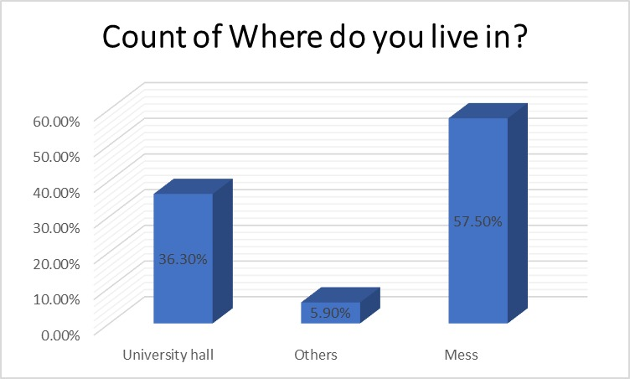Place**:**

Figure 3.3: Accommodation of participants

The horizontal bar graph provides a brief summary of the available options for students in regard to housing options. According to the graph, living arrangements were divided into three categories, which are 'mess', 'university hall' and 'others.

The longest bar shows the most common option Mess, where 184 participants live . Considering their prices and communal living benefits, meal services, among other features, it seems like a majority of students like mess accommodations. The second most popular choice.

University Hall-118 is a considerable body of the student community. The controlled spaces, easy access to campus, services, and activities put out for the students make university halls a joy to live in.

Others, 18, represent many students living with their families or in non-traditional housing units such as private rentals.

## **3.5 Data analysis method**

The chosen analytical techniques—which include both descriptive and inferential statistics—are essential for carrying out a thorough examination of the data, especially when done on a small scale. The research population's demographics may be summarized and understood, and important issues that might surface from the data can be highlighted, all thanks to descriptive statistics. We can clearly depict the profiles of the student population and capture important traits by using statistics like bar graph, pie chart.  
  
Based on the conclusions gained from our sample data, inferential statistics will enable us to draw more generalizations about the overall student population in addition to descriptive statistics.  
  
Well-organized tables and graphs will be used to visually show the data in order to improve clarity and assist understanding. The data will be easier to access with the aid of these visuals, which will also help stakeholders understand the main conclusions more clearly. We may obtain a nuanced view of the data by combining the two analytical approaches, opening the door for well-informed decision-making and focused student population actions. All things considered, this analytical framework will offer a strong basis for additional investigation and study of the pertinent problems.

## **3.6 Ethical consideration and data reliability and validity**

The following measures are taken to ensure the reliability and validity of the survey.

Reliability: The questionnaire will be tested with a sample of students outside the study population for stability and reliability. A Cronbach alpha score of 0.70 or higher would indicate satisfactory reliability.

Quality: We will confer with subject matter experts who can verify that our evaluation instrument accurately measures the objectives in order to assure content validity. Furthermore, factor analysis will be used to verify construct validity, enabling us to ascertain whether the survey items accurately reflect the variables that we anticipate to affect food pleasure.

**RESULT AND DISCUSSION**

# 4. Result and discussion:

This section presents and analyzes the findings of the study on "Food Satisfaction among the Students of Begum Rokeya University, Rangpur." The demographic segmentation of participants is based on gender, age, accommodation, family income, and personal income. These variables are examined to understand their influence on food satisfaction. The results are presented through relevant graphs and interpreted in the context of the research objectives, focusing on insights that inform practical recommendations for improving food services.

## **4.1 Family background:**

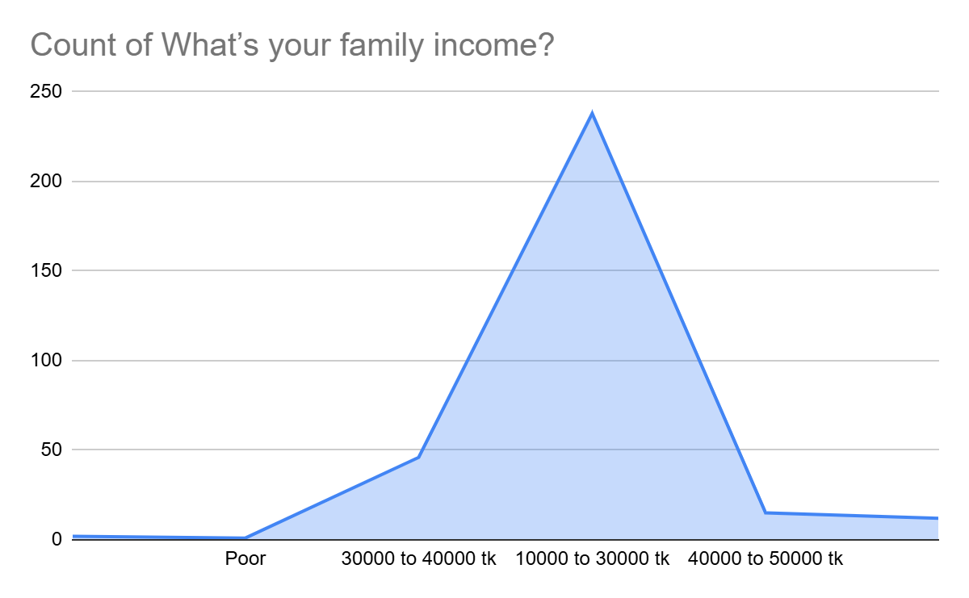

Figure 3.4: Family income

It shows the distribution of family income among the students of Begum Rokeya University, Rangpur. The x-axis represents different income ranges: **Poor**, **30000 to 40000 taka**, **10000 to 30000 taka**, and **40000 to 50000 tk**. The y-axis represents the count of respondents, ranging from 0 to 250.

This income range **10,000 to 30,000 taka** has the highest number of respondents, with the count peaking at around 225. The **30000-to-40000-taka**, **Poor**, and **40000-to-50000-taka** income ranges have significantly lower counts, with close to zero respondents in these categories.

The graph provides valuable insight into the economic background of the students, which is crucial for the dissertation on **"Food Satisfaction among the Students of Begum Rokeya University, Rangpur."** Understanding the family income distribution helps in analyzing how economic factors might influence food satisfaction among the students. For instance, students from lower-income families may have different expectations and satisfaction levels compared to those from higher-income families. Identifying the predominant income group (10,000 to 30,000 taka) allows for targeted improvements in food services that are affordable and satisfactory for the majority of the students.

This data can also assist the university in allocating resources efficiently to address the needs and preferences of students from various economic backgrounds. The graph reveals that most students come from families with an income range of 10,000 to 30,000 tk. This demographic information is essential for understanding the context of food satisfaction and making informed recommendations to enhance the food services at the university.

## **4.2 Personal income:**

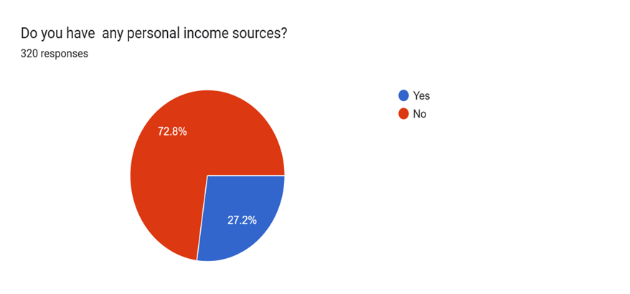

Figure 3.4: Personal income

The percentage of participants who reported having a personal income was just 27.2%. This suggests that the vast majority of students (72.8%) rely on outside or family for financial support.  
Food dissatisfaction among people without a personal income is probably impacted by the cost and caliber of dining options.  
Levels of Satisfaction:  
  
Yes (27.2%): People in this group regard the food to be good, perhaps because their personal income gives them more financial flexibility to choose from better or more favored meal options.  
No (72.8%): This bigger group expresses discontent, most likely because university dining facilities have limitations in terms of food quality, price, flavor, or hygienic requirements.

The majority of students do not have personal income, which emphasizes how important inexpensive food options are. They may be forced to sacrifice flavor, diversity, or nutritional value as a result of this dependence, which would increase their discontent.  
Students may think that the food served in the dining halls is unsatisfactory in terms of flavor, quantity, or cleanliness. Although it takes time and work, cooking for oneself is frequently more economical and rewarding for those who do it.  
  
The expense of meals continues to be a major deterrent to pleasure for students without personal income. For a larger population, meal subsidies or reduced meal prices may increase accessibility and satisfaction.

## **4.3 Food Satisfaction Among Students :**

Table 4.1 : Food Satisfaction Among Students of Begum Rokeya University, Rangpur

|  |  |  |
| --- | --- | --- |
| Response | Percentage | Number of Responses |
| Yes | 34.3% | 109 |
| No | 65.7% | 209 |
| Total | 100% | 318 |

The table presents a concise summary of the students' responses regarding their satisfaction

**Response "Yes" (34.3%):** Out of the total 318 respondents, 109 students (34.3%) reported satisfaction with the food.This satisfaction occurs because either they stay home or they cook for themselves. This minority indicates that only about one-third of the student body finds the food quality, taste, pricing, or overall dining experience acceptable.

**Response "No" (65.7%)**: A significant majority—209 students (65.7%)—expressed dissatisfaction with the food services. This highlights critical areas requiring improvement, such as taste, hygiene, pricing, menu diversity, or food quantity.

**Total Responses (100%):** The data set comprises 318 responses, ensuring a comprehensive representation of the student population and offering a reliable basis for analyzing trends and deriving insights.

The high dissatisfaction ratio indicates that urgent reforms in food services of the university are highly required. Hygiene, pricing, menu diversity, and food quality emerge as some of the critical areas in which intervention is required. Addressing such issues allows improving satisfaction levels, thus enabling positive contributions toward students' overall well-being and academic performance.

Addressing these will be immensely helpful in creating a dining experience that contributes positively to the overall university life of students. The analysis provides a clear direction for targeted reforms, which opens a way toward a more satisfactory and inclusive food service system. Efforts like these will contribute not only toward raising satisfaction levels but also toward a healthier and supportive campus environment.

## **4.4 Availability of Nutritional Food Among Students:**

Table 4.2: Available nutritional food Among Students of Begum Rokeya University, Rangpur

|  |  |  |
| --- | --- | --- |
| Response | Percentage | Number of Responses |
| Yes | 38.5% | 122 |
| No | 61.5% | 195 |
| Total | 100% | 317 |

The table provides a detailed summary of the students’ responses regarding the availability of nutritional food at Begum Rokeya University, Rangpur. It highlights the extent to which students perceive their access to nutritious meals, shedding light on an essential aspect of student welfare.

**"Yes" Response (38.5%):**

A total of 122 students (38.5%) reported that they have access to nutritional food.

This minority respondent gets the nutritious food from personal source rather their hall dining or mess cook. Again, it is suggesting that less than half of the student population considers the food options available as meeting nutritional standards.

**"No" Response (61.5%):**

A significant majority of 195 students (61.5%) expressed that nutritional food is not adequately available.

This indicates a gap in meeting the basic dietary needs of students, which could adversely impact their health, well-being, and academic performance.

**Total Responses (100%):**

The data set comprises 317 responses, ensuring comprehensive representation of the student body.

This sample size is a good basis on which trends can be found and the general perception of university food nutrition can be conceptualized.

This is supported by the data showing that 61.5% believe there is a lack of availability of healthy food, indicating a situation that can seriously impact their lifestyles. Food may be considered not available for reasons such as lack of meal variety, low quality of food, quantity of portion size, or affordability. Lack of access to nutritional food could lead to long-term complications such as low energy levels, lack of proper concentration, and health effects.

The following table corresponds to the broader focus on Food Satisfaction Among Students of Begum Rokeya University, Rangpur, and extends this critical insight into the availability of nutritious options. The findings underline the imperative of priority toward nutritional quality in food service to contribute toward the well-being and academic success of students.

By addressing these issues, the university can further develop a healthier and more supportive atmosphere for students on campus.

## **4.5 Food consumption and satisfaction from university cafeteria:**

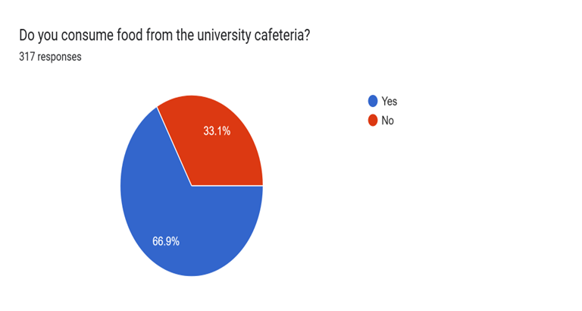

Figure 4.1: Food consumer from the university cafeteria

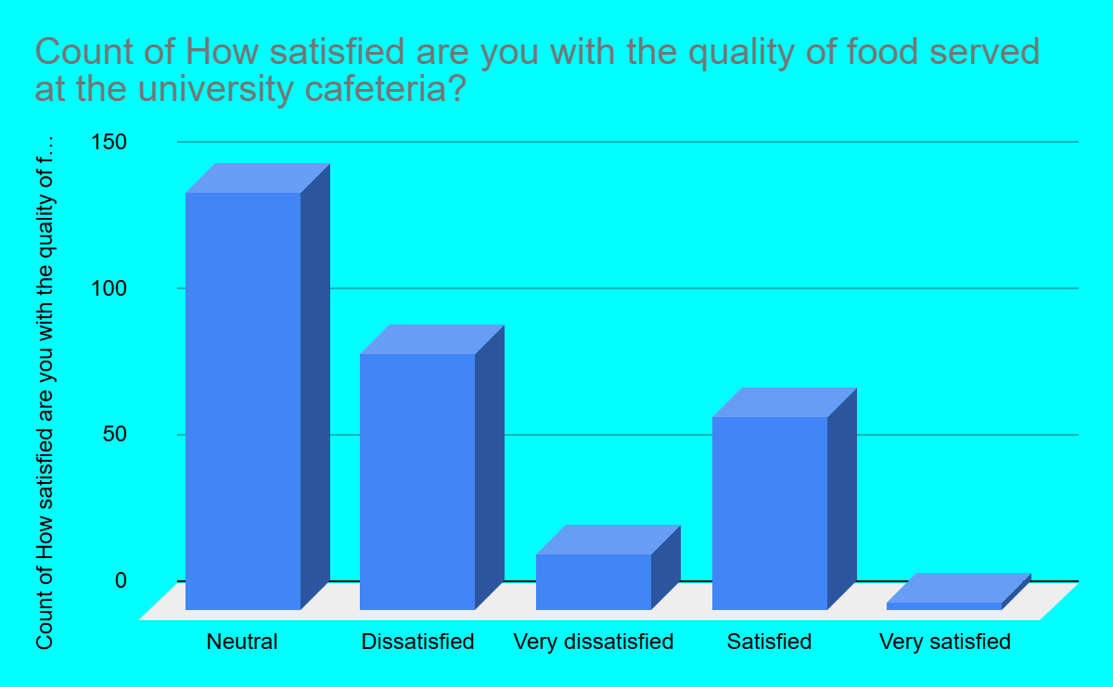

Figure 4.2: food sanctification status from cafeteria

The image contains two charts based on surveys regarding the university cafeteria. The first chart focuses on the consumption of cafeteria food, showing that 66.9% of students do not consume food from the cafeteria (represented by the red segment), while only 33.1% of students eat there (represented by the blue segment). This indicates that a majority of students choose not to eat at the cafeteria.

The second chart assesses the satisfaction with food quality among those who do consume cafeteria food. The responses reveal a mix of opinions: 20.7% of respondents are satisfied with the food quality, 44.8% feel neutral, 0.9% are very satisfied, 27.6% are dissatisfied, and 6% are very dissatisfied. This distribution suggests that, while some students are content with the food, a significant portion either feels indifferent or dissatisfied with the quality, indicating room for improvement.

These charts highlight that although a considerable portion of students avoid the cafeteria, the food quality for those who do eat there is met with mixed reactions. The dissatisfaction among a notable portion of students and the high percentage of neutral responses suggest that the cafeteria may need to address issues related to food quality to improve customer satisfaction.

## **4.6 Factors influencing students’ food satisfaction:**

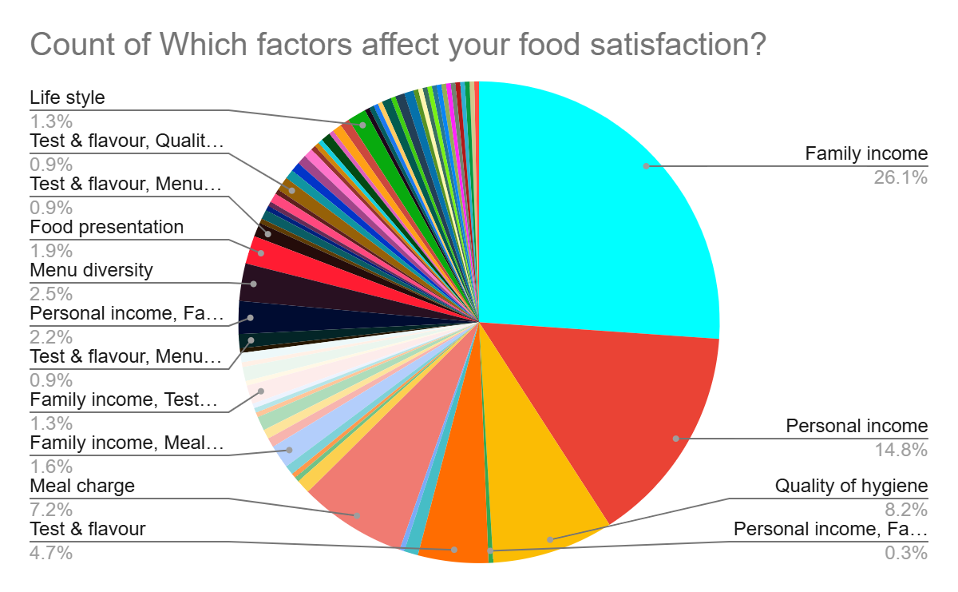

Figure 4.3: Factors affected food satisfaction

The survey results provide a detailed breakdown of factors that influence university students’ food satisfaction. These factors reveal what they prioritize when it comes to their dining experiences, and understanding these preferences can help administration focus on key areas to improve students’ food satisfaction. Below is a detailed explanation of the factors, ranked according to their importance:

Family income was the most important factor in food satisfaction, as 144 (45.3%) responded to this. This indicates that almost half thought that their family income dictated whether or not they had access to good food. Students from higher-income families may have more money to spend on eating out and, thus, be more concerned about factors like the variety of food, quality of food, and taste of food. This finding emphasizes the economic aspect of dining satisfaction and points to the need to align the prices and offerings of the menu items with the income levels.

The quality of hygiene ranks second with 92 responses or 28.9%. Food preparation and serving areas should be clean to satisfy the students. Hygiene is related to health and safety issues, and they expect their food to be prepared in hygienic conditions. This finding indicates that dining and cafeteria food service providers should commit themselves to ensuring that the kitchen and dining areas have high standards of cleanliness to instill trust among students. Personal income, with 95 responses (29.9%), reflects the significant role an individual's income level plays in food satisfaction. Those with higher personal income levels would likely pursue high quality in food experiences, focusing on menu variety, portion size, and quality of food. This factor may indicate that different income classes have different expectations for food satisfaction.

The meal charge, at 90 (28.3%), is the other major driver. Price sensitivity can be seen from the fact that a large number of students are anxious about the cost of their meals in relation to the service they get. They want to make sure that the food they purchase gives good value for money, and this driver therefore suggests competitive pricing and perceived value are key to their overall satisfaction.

Food taste and flavor, though important, is ranked lower with 78 responses, which constitutes 24.5%. This shows that though flavor matters, it is not as crucial as the factors above, such as hygiene, income, and cost of meals. At the same time, however, food served to them should not disregard their being able to eat delectable meals since flavor is always one of the core elements of food satisfaction.

Menu diversity received 44 responses, which accounted for 13.8%; thus, the variety in the menu is welcomed but relatively less valued compared to other reasons. The students enjoy having different options to choose from, but it seems they rate other factors higher, such as taste, price, and hygiene.

Food presentation is low, placing it with 36 responses at 11.3%, meaning that while food presentation may be important, it will be less of a factor than taste and hygiene, among others. This means that students are more concerned about the content of their meals rather than how the meals look, although good presentation would still go a long way in enhancing the meal.

Lifestyle, with 27 responses (8.5%), is the least crucial variable. This seems to indicate that such factors as dieting preferences or lifestyle choices-vegetarian, vegan-have the least significant consequence on food satisfaction. Even though lifestyle can be a factor for some customers, it isn't as important to the majority of the respondents.

The study underlines that ‘family income’ is the biggest factor which affects food satisfaction: 45.3% of the respondents acknowledge its impact, and this points to the very economic aspect of dinner preferences. Close to this comes ‘personal income’ (29.9%), ‘Hygiene’ ranks second with 28.9%, while ‘meal charge’ takes a significant position in the ratings (28.3%), which evidences price sensitivity and, correspondingly, the value-for-money perception.

While ‘taste and flavor’ (24.5%) remain fundamental, they are less important compared to the two hygiene and economic factors. Further, ‘menu diversity’ accounts for 13.8%, and ‘food presentation’ accounts for 11.3%; these factors are valued but rated rather low, which indicates a view that substance is more valued than presentation and variety. Finally, ‘lifestyle preferences’ have the least impact, with 8.5%, indicating dietary choices as a concern for the few. This comparison thus shows a prioritized hierarchy, first of financial and hygiene-related issues, followed by aesthetic and lifestyle priorities.

## **4.7 Suggestion from students’ point of view:**

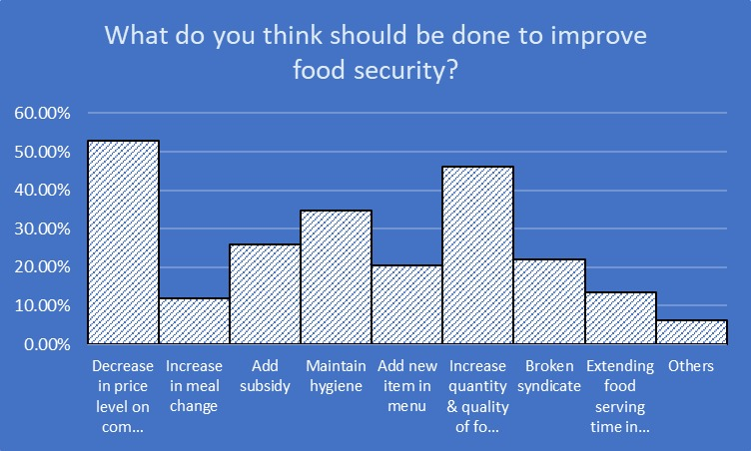

Figure 4.4: Factors for improving food satisfaction

This study offers a detailed look into the views of students at Begum Rokeya University, Rangpur, on the essential measures needed to boost food security. The survey garnered 318 responses, highlighting a range of recommendations aimed at improving food security, a vital element of student life that significantly affects their health, well-being, and academic success.

A decrease in the price level of commodities (52.8%) stands out as the most significant finding from this survey, with over half of the respondents (52.8%) indicating that it is the most effective strategy to enhance food security. This highlights the critical role of affordability in food access. Elevated food prices can pose a significant challenge for students, especially those from lower-income backgrounds. By lowering prices, the university can provide healthier food options to a broader segment of the student population, ensuring that financial limitations do not force students to compromise their health**.**

Only 11.9% of the respondents indicated that increasing the meal change would improve food security. This relatively low percentage suggests that while students value variety, it is not viewed as a crucial element. This may indicate that the availability and affordability of meals are more significant issues for students than simply expanding the variety of meal options.

Approximately 25.8% of students think that introducing subsidies would enhance food security. Subsidies can significantly reduce food costs for students, especially those facing economic challenges. By implementing subsidies, we could ease some of the financial strain on students, allowing them to obtain regular, nutritious meals more easily. This idea resonates with the large number of students calling for lower food prices, highlighting a major concern regarding financial obstacles to food security.

A significant number of respondents (34.6%) emphasized the importance of hygiene. This shows that students care not just about having food available, but also about the cleanliness and safety of what they eat. Inadequate hygiene can result in foodborne illnesses, impacting students' health and, in turn, their academic success. It's crucial to maintain high hygiene standards in food preparation and serving areas to avoid these problems and improve students' overall satisfaction with food services.

About 20.4% of the students expressed interest in adding new items to the menu. This feedback highlights a desire for greater variety and diversity in the food options available. Although it may not be the main issue, a more diverse menu can enhance the overall dining experience, accommodate various dietary needs, and provide students with a broader range of nutrients.

Almost half of the participants (46.2%) feel that enhancing both the quantity and quality of food is crucial for bolstering food security. This underscores the significance of not only having sufficient food but also making sure it is nutritious and of excellent quality. Providing an adequate amount of high-quality food is essential for fulfilling students' dietary requirements and promoting their physical and mental well-being.

The phrase "broken syndicate" accounted for 22% of the responses, indicating a desire to dismantle monopolies or cartels that may be influencing food prices and availability. Tackling these concerns could foster more competitive pricing and enhance the quality of food options for students. Promoting fair market practices can contribute to lowering prices and elevating the overall standard of food services.

A suggestion to extend food serving times in the canteen was made by 13.5% of respondents. This suggests that some students might struggle to access food during the current serving hours. By extending these times, it could offer greater flexibility for students with different schedules, ensuring they have access to meals throughout the day, which is essential for those balancing busy academic or extracurricular activities.

A small percentage (6.3%) of respondents chose "Others," reflecting additional concerns or suggestions that weren't included in the given options. This category may encompass various issues, such as specific dietary requirements or enhancements to the dining atmosphere.

The survey results offer a detailed perspective on what students at Begum Rokeya University, Rangpur, consider crucial for enhancing food security. Key concerns include affordability, quantity, quality, and hygiene. A significant number of students highlight the importance of competitive pricing, access to sufficient and nutritious food, and the need for high hygiene standards. By focusing on these aspects, we can make meaningful strides in improving food security, which is essential for supporting students' health and academic success. These findings are important for developing informed recommendations and effective strategies to boost food satisfaction among the student body.

In conclusion, the results of the surveys and tables on students' meal satisfaction and nutritional availability at Begum Rokeya University in Rangpur offer a clear understanding of the main elements affecting their dining experiences. Significant inadequacies in the current food services are highlighted by the majority of students' unhappiness with both the availability of healthful options and the quality of the meals. Taste, meal quality, price, and hygiene have the most effects on eating satisfaction. In addition to increasing overall satisfaction, addressing these issues—particularly by reducing meal costs, enhancing food quality, upholding strict sanitary standards, and guaranteeing a varied and nourishing menu—will also boost students' academic performance and general well-being. Furthermore, expanding serving hours, addressing monopolistic practices, and implementing subsidies could all contribute to making food services more egalitarian and accessible for all students. Given these results, it is evident that immediate changes are required to establish a more encouraging and fulfilling campus eating experience.

## **4.8 Case study**

4.8.1 Case study

The Director of the Cafeteria at Begum Rokeya University gave an overview of the present state of the cafeteria. The new administration has already prepared a number of light and heavy meals in the cafeteria at prices lower than market prices. According to him, the staff maintain adequate hygiene. Each cafeteria tries to adjust the growing demands of the students by ensuring the quantity, quality, and nutritional values of the food are according to the increasing price of the products in the market.

The challenges facing cafeteria management, urgent action has to be taken to resolve the most serious problems that include manpower shortages, rising prices, and low cleanliness. Addressing the manpower problem requires an increase in administrative funding. It is important to take measures that will stabilize inflation in the market, as increased raw material costs directly impact students' meal affordability and accessibility.

We, therefore, propose a slight increase in food prices to cover the increased operational expenses as a measure of ensuring the cafeteria remains financially sustainable while serving quality food. However, this should be paired with subsidies for students, ensuring affordability without compromising quality or nutrition. Subsidies could bridge the gap, making meals accessible to all while maintaining operational efficiency. Prioritizing cleanliness is equally important; hiring more sweepers could address this issue. These combined measures would not only solve immediate challenges but also create a sustainable and student-focused cafeteria environment.

**4.8.2 Case study**

An Assistant Provost of Sohid Mukhtar Elahi Hall at Begum Rokeya University, Rangpur shared the prevailing dining scenario at the hall. According to him, the food available at Hall includes fish curry, dal, egg, one piece of chicken, vegetable curry, and unlimited rice, all for 40 BDT per meal. He said the hygiene standards maintained in the dining hall are adequate. The dining staff are paid a sum of 9,000 to 10,000 BDT per month by the administration. While the quality of food in the hall is considered better than outside food, the quantity is somewhat smaller. Two meals are served daily: one at noon and one at night.

The dining experience at Sohid Mukhtar Elahi Hall, we find the current scenario to be a concoction of strengths and challenges. Meals available-fish curry, dal, egg, chicken, vegetable curry, and unlimited rice for only 40 taka-are very cheap, and hygiene maintained in the dining hall is appreciable. Compared to outside food, the quality is no doubt better. However, the reduced portion sizes and limited selection could make some students not be too inclined to have hall dining. The lack of interest not only cuts revenue but also makes managers not be too keen on managing their facilities. The small profits thus form a vicious circle where fewer resources are being used to enhance the service, making it less attractive to the students. These issues would necessitate a focus on the affordability-quality-operational sustainability nexus as methods of making hall dining more attractive for students. The meal charge could be increased moderately to improve financial sustainability without causing excessive burden for students.

Thirdly, decision-making with the involvement of students would ensure that the dining service fits better with their taste and needs. Getting involved with the District Commissioner's office could stabilize costs, along with increased inflation rates, and increasing the dining budget can improve both quality and service. Turning off heaters may be practical in reducing the cost, but not if students' comfort is drastically compromised. With these modifications, I feel that hall dining could be made more attractive and viable for both students and management alike.

**4.8.3 Case study**

Hall Provosts of Begum Rokeya University, Rangpur shared his insights regarding the food security and satisfaction at the university. According to Sir, though food security is positive, food satisfaction is presently negative because of the ongoing inflation and high raw material costs, which reduces the capacity to feed the students enough to satisfy their demand. Although food in the university halls is subsidized, the subsidy itself does not go toward the food. An average of 60,000 Taka per month is paid to the employees working in the subsidized system. If the administration did not pay this amount, then students would have to cover this extra cost on top of what they already pay for food.

He advocated increasing the prices of foods as a means of increasing food satisfaction, though he reiterated this is not possible as most students come from low-income families and therefore could not afford more costly prices. Food quality can be highly improved by consolidating dining services of the two halls, although he added the rising costs of goods are a big challenge. On the other hand, increasing food quality is possible if the administration increases subsidies. This may be supported by an increase in the budget of the university's budget from the government. Closing off heaters in halls can also lower expenses that can be utilized by the university to increase the quality of food. Sir recommends increasing student participation in hall dining as one way of increasing dining experience.

Improving food satisfaction among university students, we recommend the following measures to address the challenges and enhance dining services effectively:

First, increasing the meal charge could provide the additional funds necessary to improve food quality and variety. For this, one must be very considerate about the paying capacity of the students. Turning off heaters in halls to reduce expenses could work practically, but this needs to be weighed against maintaining a comfortable environment for students.

Consolidating dining services for both halls may reduce redundancy, lower costs, and create a streamlined operation that makes better use of resources. Additionally, we advocate for an increased subsidy from the administration, since this would help offset costs without additional burden on students. Efforts should be made to control the inflation rate since rising food prices affects heavily on affordability and satisfaction.

Finally, a greater share of the university budget needs to go toward food services so that sustainability in upgrading meal and dining conditions can be achieved for the students.

**4.8.4 Case study**

We believe both quality and affordability are the two most important elements of dining; hence, students' feedback about staying in the hall is quite telling about the challenges and opportunities for improvement. According to one student, she avoids hall dining because of the poor taste, high costs, untimely service, and scant nutrition within such meals. She cooks for herself because it gives better satisfaction and helps her manage her monthly expenditures more appropriately. This stresses that dining services need to emphasize the provision of enjoyable yet economical meals.

One other student provided a different viewpoint, stating there has been a lot of improvement in the boys' dining service since its management came into the hands of students. He observed improved food quality, better presentation, improved nutrition, and improved hygiene standards. This goes to show that proper management, coupled with attention to other crucial determinants like taste and cleanliness, hall dining could be a little more pleasing and reliable for students. This insight could be interpreted to the effect that if students can be included in the management or decision-making of dining-related activities, then constructive changes in food catering at halls could soon be possible.

We understand through these different changes the need to address current challenges and enhance students' needs. Increasing the quantity of food served is essential to ensure meals are filling and meet dietary requirements. At the same time, the cook and preparation method should not include compromise in hygiene to build trust in their health. Of equal importance to making dining services accessible to all students, especially those with limited financial resources, would be the reduction of meal charges. Efforts should also be made to improve flavors and qualities; after all, the taste of a meal greatly affects satisfaction. A greater menu variety would cater to different tastes and preferences, thereby making dining more attractive. Finally, subsidizing dining services would improve their quality without raising costs on students, finding a balance between affordability, nutrition, and quality. Taken all together, this would be one of those dining services that actually take care of the well-being and satisfaction of the students.

## **4.9 Result Discussion and Suggestion:**

### 4.9.1 Discussion

The present study on food satisfaction among Begum Rokeya University, Rangpur students has shown that a significant number of students in the university population are displeased with the current food services. An surprising 65.7% of students showed dissatisfaction, indicating serious concerns regarding quality, hygienic situation, price, and variety of meal packages available. Remarkably, only 34.3% reported being satisfied, which means that a majority of students' expectations are not being satisfied with the current food available.  As many as 61.5% reported that the failure of students to access nutritious food compounds the situation and can affect students' overall life, academic performance as well as their health status. These findings point to an urgent need for food availability and improvement in quality to ensure the pupils get safe, and affordable food.

With 45.3% of respondents saying that their income level significantly influences their capacity to get high-quality food, family income stood out as the most significant driver. This emphasizes the necessity for food services to match their offers with students' financial means and draws attention to the economic inequalities that exist among the student body.

About 28.9% of students emphasized the significance of hygienic quality, making it the second most important aspect.The students attach great importance to cleanliness of areas where food is prepared and served. A more representative and equitable food service system is also needed-as evidenced by the request for lowering meal costs-and increasing quality and variety. Similarly, addressing these issues will lead to an increase in food satisfaction and-as a consequence of increased good health-will result in better academic performance. Faculty and students alike report that Begum Rokeya University is facing several issues in its dining services: increasing food prices, a shortage of staff, and inferior meal quantity and quality. Again students point out that issues such as high prices, cooking, and the need for more variety and quantity are essential. All these concentrations indicate that some structural changes are needed to make eating services more accessible and attractive for students

### 4.9.2 Suggestion

Based on the findings, several recommendations may be proposed to improve food security and satisfaction of the students’ of Begum Rokeya University, Rangpur.

1. Students' meals at Begum Rokeya University, Rangpur should be more affordable. About a quarter of the students emphasized that reduction of food costs is an important means of making meals more affordable, especially for those who are from lower income family background.
2. Subsidies could also help ease the financial load and make healthy meals more affordable for a greater number of students.
3. Since the hygiene of food service was considered an essential factor by students in food pleasure, improving the food quality and hygienic situation of food services should be a top priority.
4. Making sure the food is prepared and served under hygienic conditions would also promote safety and health.
5. V. Increasing the variety of the menu would add to several tastes and dietary needs, creating a more enjoyable dining experience.
6. A fair and more functional food provision system could be created by addressing the logistical issues with food delivery, like extending cafeteria operating hours and stimulating reasonable prices through eliminating monopolistic practices.
7. To maintain the food quality without giving students an excessive burden, the improvement of administrative support should be performed, such as food price enhancement according to the cost increase and subsidy.
8. More financial support and cafeteria rental exemption are the supporting suggestions for the whole improvement.
9. To make the meal affordable and full-fledged, food flavor enhancement, menu variety should increase and meal prices cut.
10. X. To save operating costs in varsity hall, combine meal services, increase student participation, and shut off heaters. These recommendations will provide a comprehensive approach toward improving standard, affordability, and satisfaction with campus dining.

CONCLUSION



# Conclusion:

The research on food satisfaction for the students of Begum Rokeya University, Rangpur has inform substantial information about how the food services influence the overall student experience, health and academic performance. This research was motivated by finding a large gap of literature on food satisfaction among student in Bangladeshi public universities. Here, the synopsis integrates the research design and a description of methodologies used in addition to key findings and discussions generated from such data collection. Using a mixed-methods approach, this research is particularly well-suited to the thorny terrain synonymous with complex social phenomena (e.g., food satisfaction). Using this approach enabled a mixed methods integration of quantitative and qualitative data to better capture factors impacting students’ food experiences. With the guiding paradigm of pragmatism, this was to allow for data that reflected observable action on the part of students rather than gardening theoretical assumptions about student behavior. The study used surveys and interviews in order to capture.

In order to guarantee wide accessibility, structured questionnaires were distributed to 320 students as part of the quantitative portion of the study using both paper copies and online platforms. The purpose of the questionnaire was to collect information on a number of topics that impact meal satisfaction, such as availability, cost, hygiene, diversity, food quality, and demography. Focus groups and interviews were part of the qualitative component, which offered more in-depth understanding of how students felt about the food services on campus. Inferential statistics were used to make generalizations about the larger student body, while descriptive statistics were used to describe the demographic traits of the respondents. A more complex knowledge of the connections between many factors and how they affect meal satisfaction was made possible by this combination of approaches.

The study's conclusions identified a number of critical elements that have a major impact on the students' eating pleasure of Begum Rokeya University, Rangpur. The results indicated that family income is the most major factor influencing food satisfaction, followed by personal income, meal costs, hygiene, flavor, and family income. Inferring from this analysis, students with higher incomes will have more financial freedom, thus increasing the propensity to achieve food satisfaction. Individuals earning less could face challenges in affording and accessing meals offered.

About 28.9% of students emphasized the significance of hygienic quality, making it the second most important aspect. This result is consistent with previous research that indicates food service sanitary standards are critical to guaranteeing the health and happiness of students. The study also discovered that overall satisfaction levels are significantly influenced by the variety and flavor of the food.

Students respect not only the cost and quality of food, but also their interactions with food service personnel, according to the qualitative data, which further enhanced the findings. The whole dining experience was shown to be improved by positive staff interactions, indicating that staff involvement and training may be crucial for raising meal satisfaction.

Additionally, the study tackled the urgent problem of food insecurity, especially among pupils from low-income families. Access to wholesome meals was found to be significantly hampered by the growing costs of essential commodities like rice. This discovery is especially pertinent to Bangladesh, where many households' food security is still impacted by economic difficulties.

The report makes a number of practical recommendations for enhancing varsity's dining services in light of these findings. These include raising the bar for cleanliness, expanding the menu to accommodate different dietary requirements, and making sure that all students, especially those from low-income families, can pay the prices. Furthermore, creating a cooperative atmosphere where students can provide input on food services may result in more specialized options that satisfy their requirements.

The study adds to the body of knowledge on food satisfaction in Bangladeshi higher education institutions and offers a framework for other universities to evaluate and enhance their food services. The knowledge acquired can help university administrators and policy makers in their attempt to provide more wholesome and encouraging campus settings that foster students' academic achievement and general well-being.

In summary, the university may improve health outcomes, promote academic performance, and improve the overall student experience by acknowledging the varied needs and preferences of the student body. The results are a wake-up call for legislators, food sellers, and university decision-makers to emphasize food satisfaction as a vital aspect of student well-being.

LIMITATIONS AND FUR

THER RESEARCH

# Limitations and further research:

There are a number of potential restrictions on our dissertation on "The Level of Food Satisfaction Among the Students of Begum Rokeya University, Rangpur" that might affect the research's conclusions. Among the possible restrictions are:

1. Due to time imitation we cannot run a regression model to analyses the factors influencing the level of food satisfaction. As a result, some point remain unexplored.
2. Data Collection Methods: Data collection methods like surveys or interviews may introduce biases, such as social desirability bias, where respondents give socially acceptable answers instead of honest ones.
3. Financial constraints: Financial constraints leading to food insecurity and impacting health, academics, and engagement. Economic disparities and self-reported data may skew results.

A regression model should be used in future studies to examine the variables affecting food satisfaction in more detail. A deep analysis of the connections with other factors, including food quality, pricing, variety, hygiene, and service, as well as their combined effects on satisfaction levels, would be possible with this statistical method. More detailed insights into factors influencing students' satisfaction with campus dining alternatives can be obtained by utilizing advanced data analysis techniques along with a bigger and more diverse sample size.

Further research could also focus on reducing biases from data collection methods to decrease biases. By using long-term data, it is possible to clearly address the budgetary constraint and unexplored the long-term effects on food satisfaction on students’ of Begum Rokeya University, Rangpur. An economic gap and their impacts could be obtained through a mixed-methods technique, including quantitative and qualitative, that will provide accurate conclusions for taking useful decisions by university administration and policymakers.

# REFERENCES



References:

Ahmed, A. U. (n.d.). Food for Education Program in Bangladesh: An Evaluation of its Impact on Educational Attainment and Food Security. 138.

Akter, S., & Basher, S. A. (n.d.). The Impacts of the Global Food and Financial Crises on Household Food Security and Economic Well-being: Evidence from Bangladesh.

Davitt, E. D., Heer, M. M., Winham, D. M., Knoblauch, S. T., & Shelley, M. C. (2021). Effects of COVID-19 on University Student Food Security. Nutrients, 13(6), 1932. https://doi.org/10.3390/nu13061932

Dessus, S., Herrera, S., & De Hoyos, R. (2008). The impact of food inflation on urban poverty and its monetary cost: Some back‐of‐the‐envelope calculations. Agricultural Economics, 39(s1), 417–429. https://doi.org/10.1111/j.1574-0862.2008.00348.x

Hassan, M. M. (n.d.). Nexus Between Food Security, Inflation, Income, And Safety Net Policies A Study Of Rural Households (2012-2014).

Hernández, P., & Camardiel, A. (2021). Association Between Socioeconomic Status, Food Security, and Dietary Diversity Among Sociology Students at the Central University of Venezuela. Frontiers in Sustainable Food Systems, 5, 623158. https://doi.org/10.3389/fsufs.2021.623158

Hiller, M. B., Winham, D. M., Knoblauch, S. T., & Shelley, M. C. (2021). Food Security Characteristics Vary for Undergraduate and Graduate Students at a Midwest University. International Journal of Environmental Research and Public Health, 18(11), 5730. https://doi.org/10.3390/ijerph18115730

Khanam, T. S., Bhandari, H., & Mohanty, S. (2015). Rice price inflation and its impact on poverty and livelihood: Insights from Bangladesh.

Morris, L. M., Smith, S., Davis, J., & Null, D. B. (2016). The Prevalence of Food Security and Insecurity Among Illinois University Students. Journal of Nutrition Education and Behavior, 48(6), 376-382.e1. https://doi.org/10.1016/j.jneb.2016.03.013

Rahman, M., & Zaman, M. U. (n.d.). New paradigm in understanding food security in Bangladesh: Experiences from fieldworks in coastal areas of southwest Bangladesh.

Raihen, M. N., Akter, S., & Sardar, M. N. (2023a). Food Satisfaction among Students: A Study of Present Public University Students in Bangladesh. Journal of Mathematics and Statistics Studies, 4(1), 01–18. https://doi.org/10.32996/jmss.2023.4.1.1

Raihen, M. N., Akter, S., & Sardar, M. N. (2023b). Food Satisfaction among Students: A Study of Present Public University Students in Bangladesh. Journal of Mathematics and Statistics Studies, 4(1), 01–18. https://doi.org/10.32996/jmss.2023.4.1.1

Saha, I., Durand-Morat, A., Nalley, L. L., Alam, M. J., & Nayga, R. (2021). Rice quality and its impacts on food security and sustainability in Bangladesh. PLOS ONE, 16(12), e0261118. https://doi.org/10.1371/journal.pone.0261118

Talukder, R. K., & Anik, A. R. (n.d.). Food Security and Nutrition Sensitive Agriculture in Bangladesh: Challenges and Opportunities.

Uddin, M. M. (n.d.). Inflation in Bangladesh and Its Impact on People’s Economic Access to Food.

# **APPENDIX**



Appendix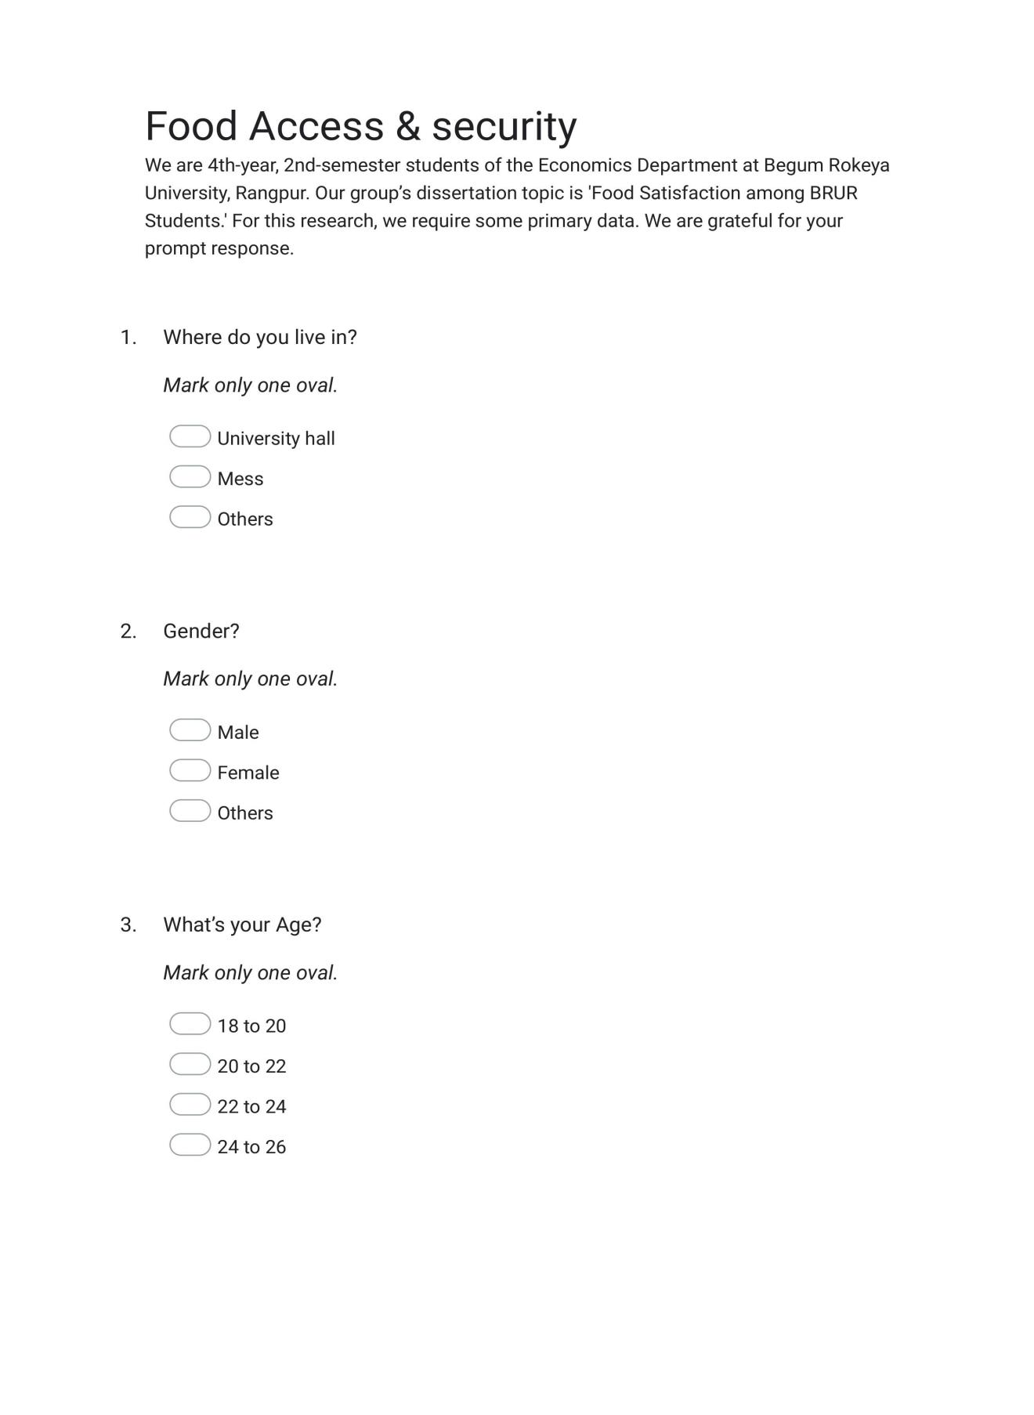

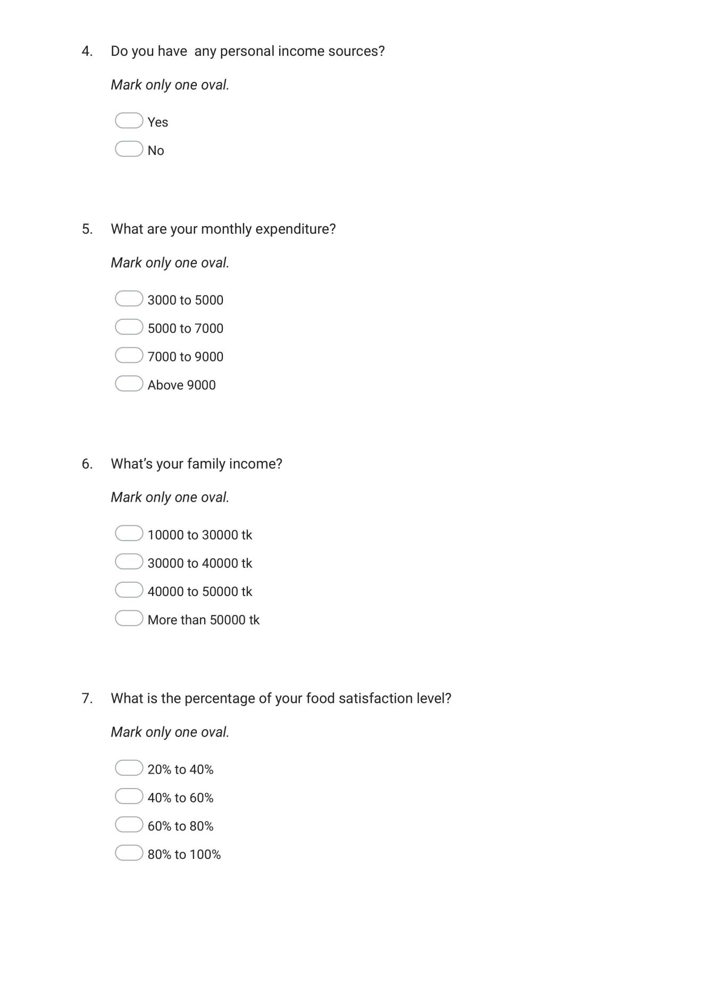

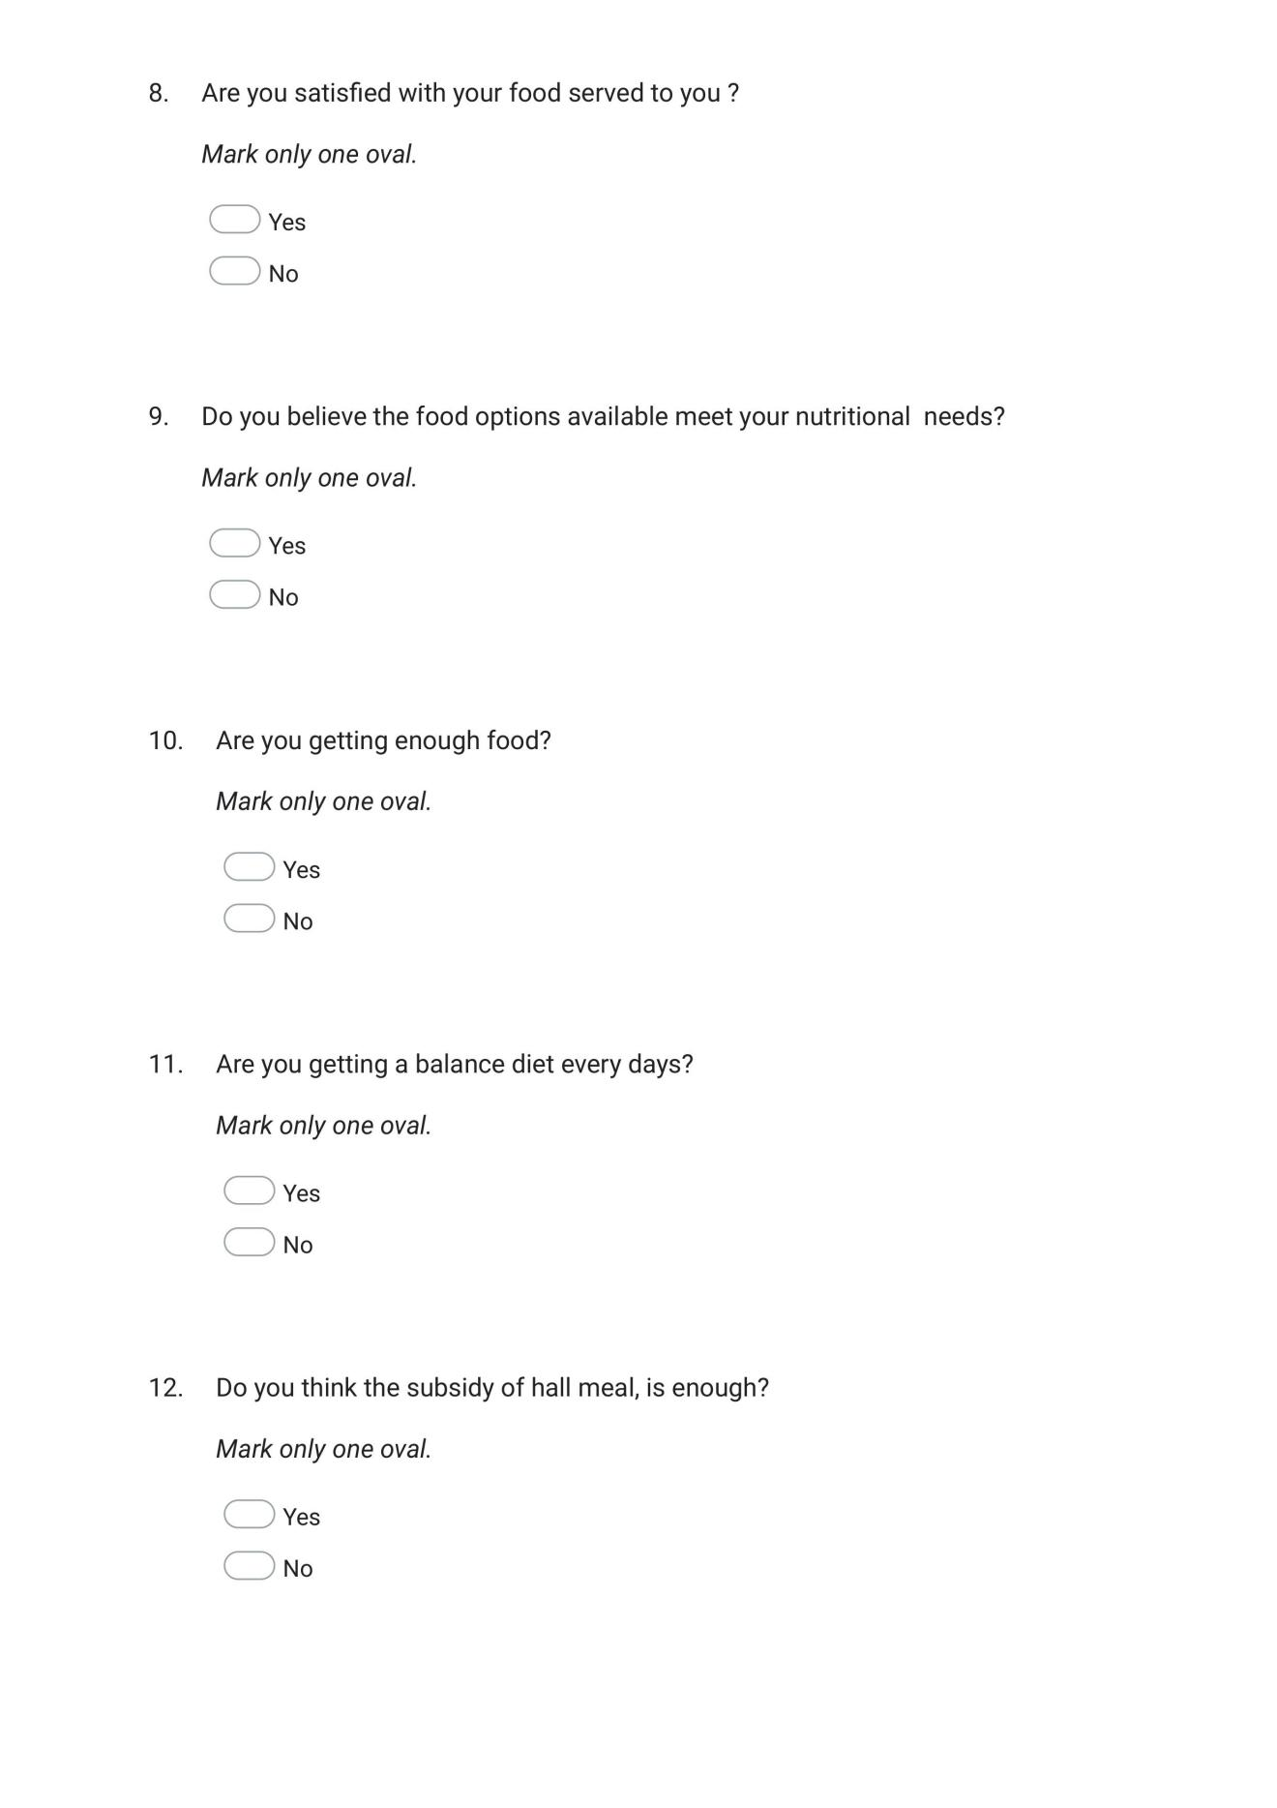

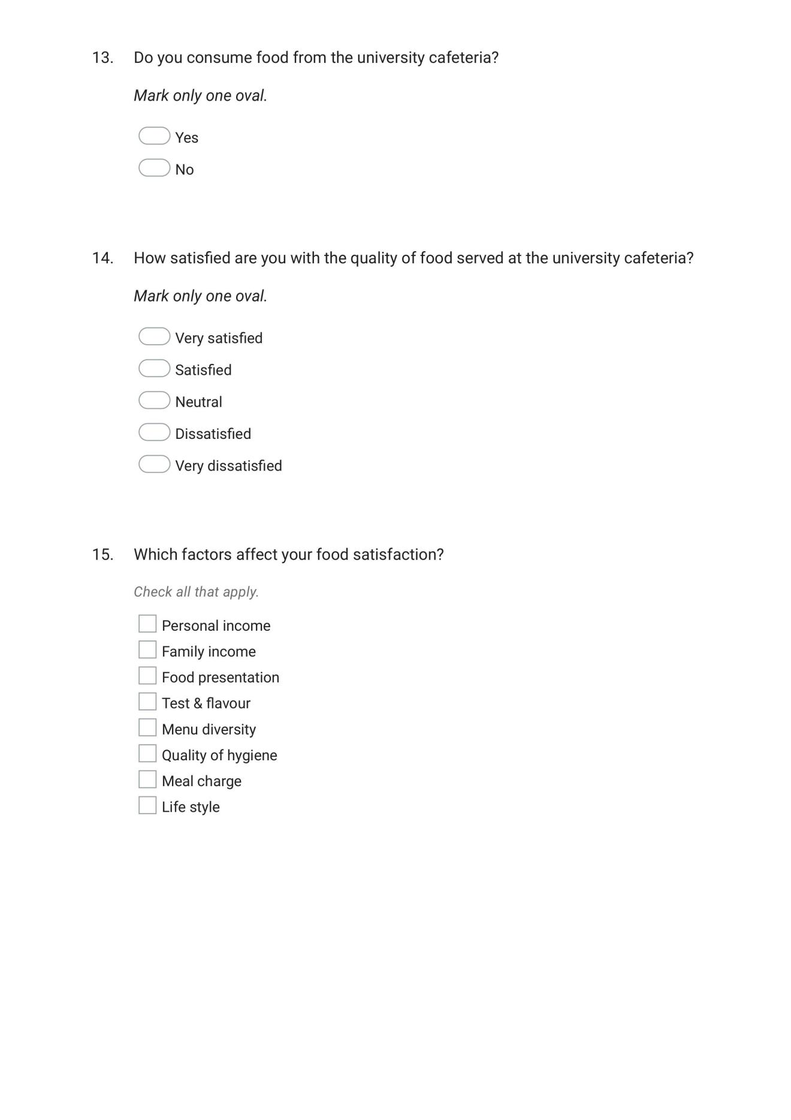

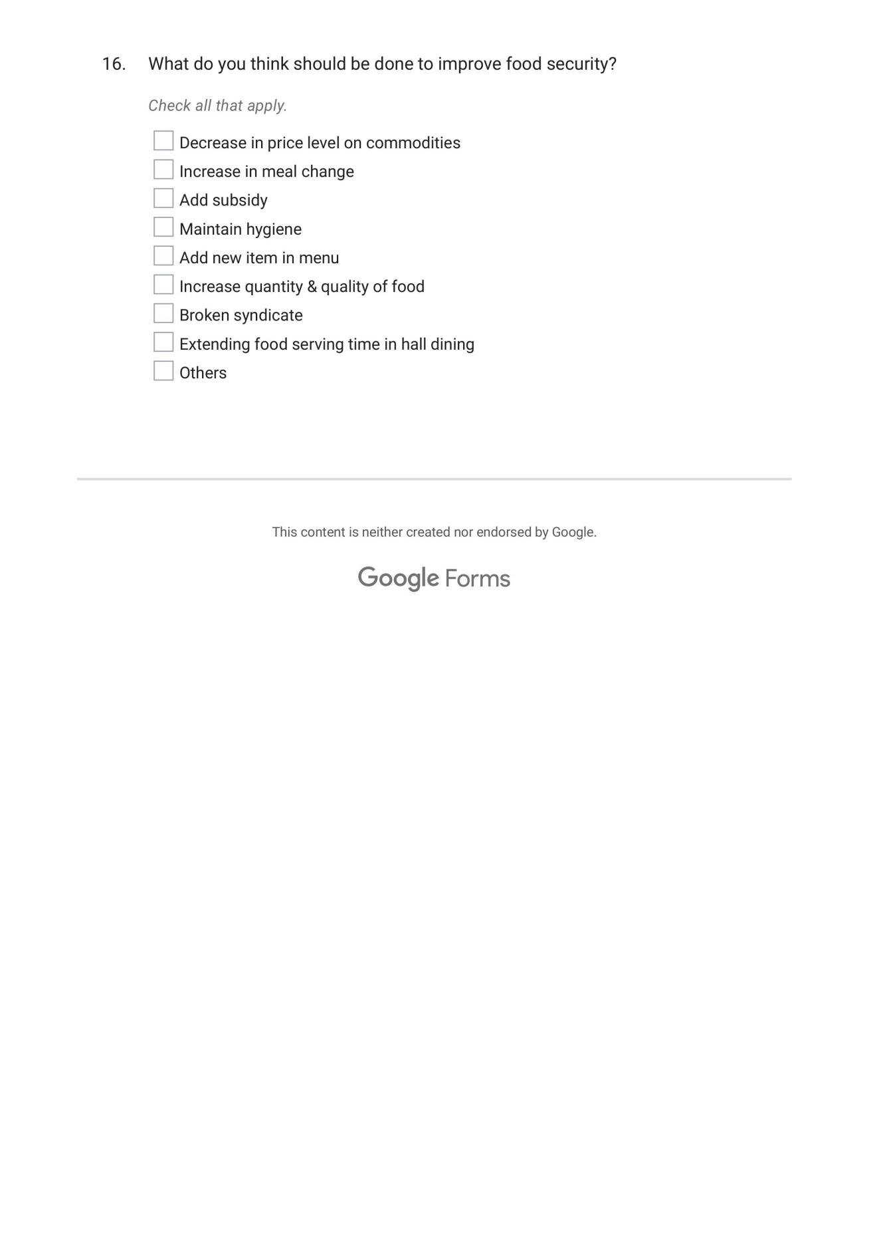

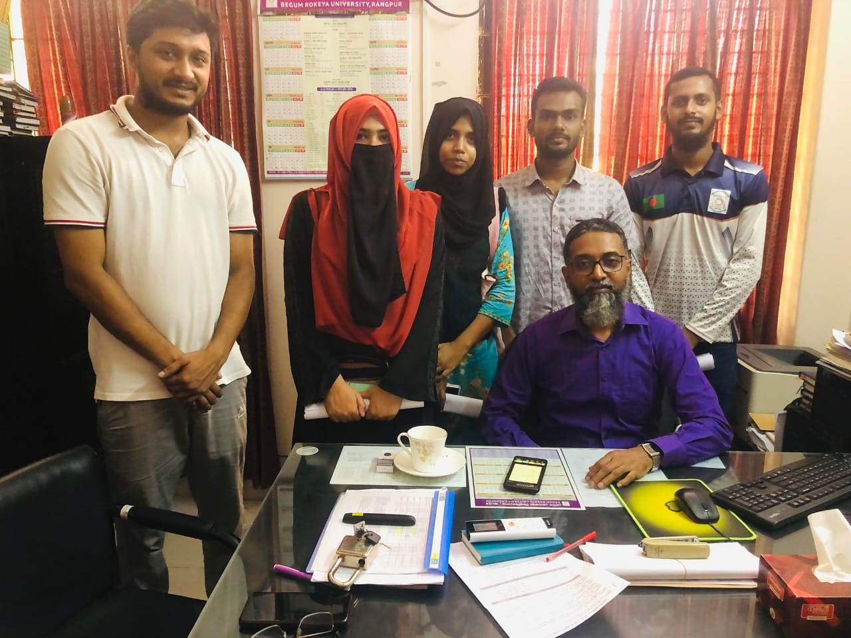

With respected Ahamed Sharif sir,Provost Bangobondhu Hall

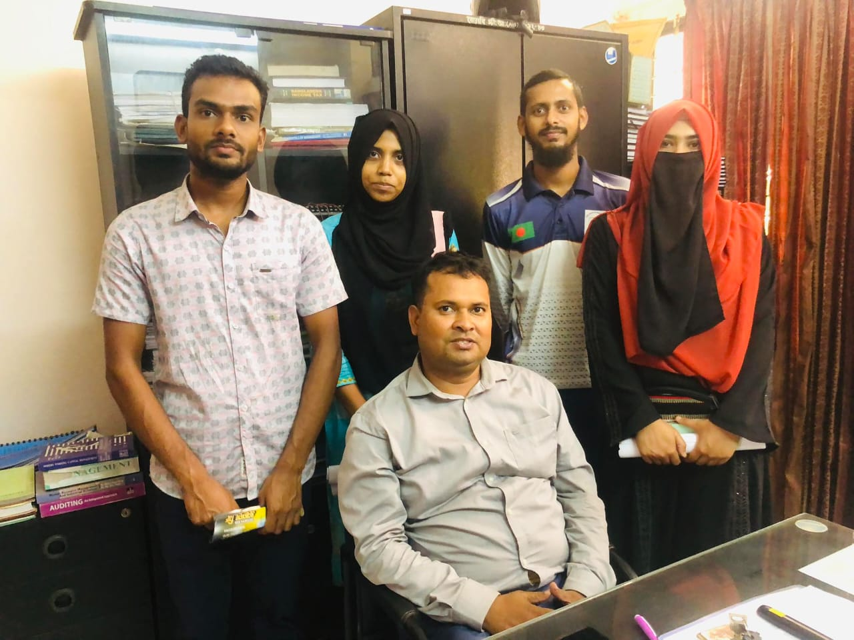

With respected Apple Mahmud sir, in the time of case study



Case study: With respected Belal Uddin sir

Fild Working Time

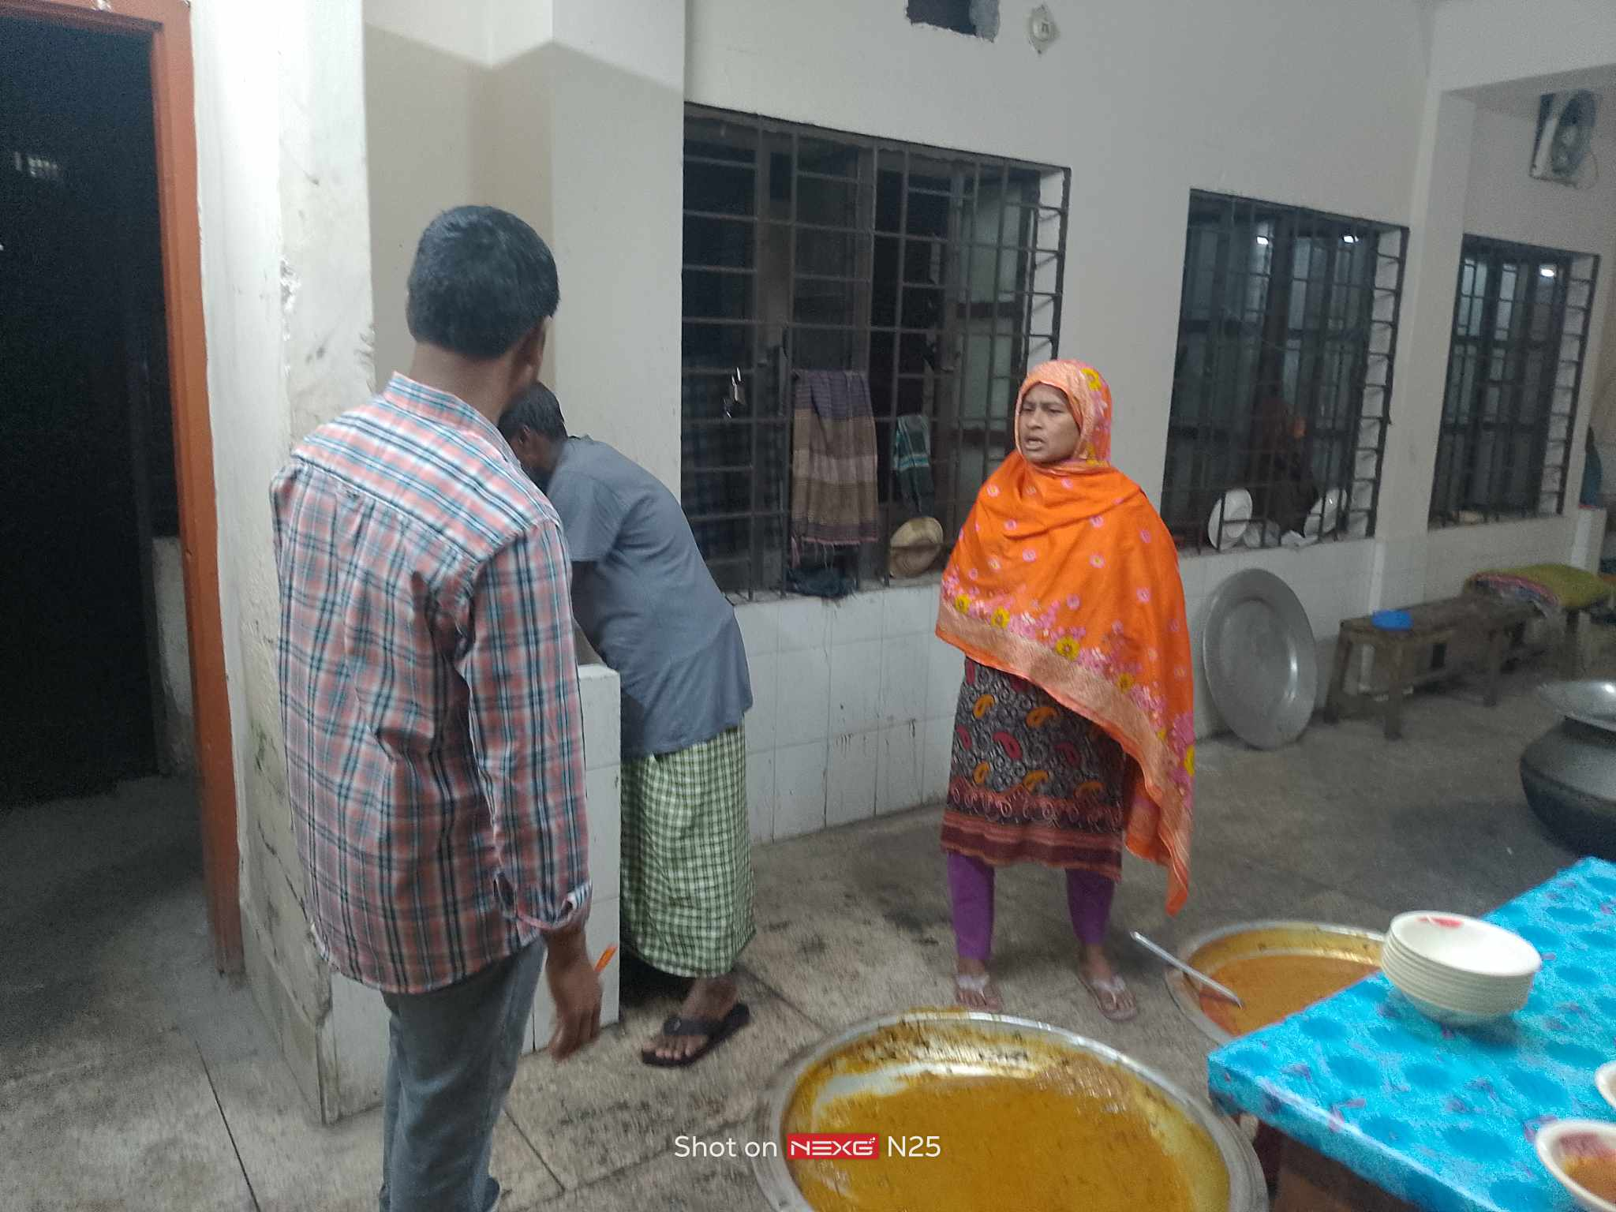

Case study and observation in Dining Mukhtar Elahi Hall